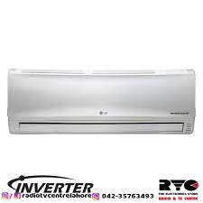

P246SQ LG

* Jet Cool Jet Dry
* 60% Energy Saving
* Auto Cleaning
* Capacity:2ton
* **Rs.118,000**